**Sall-e: Autonomous Robot for Oceanic Garbage Collection**

# 1. Attach the Assignment Cover Page

(Available in Module>Forms and Documents Folder)

# 2. Executive Summary

A brief summary of the proposal in not more than one page.

Emphasis: highlighting of the proposed technical and management approach

Table of Contents

1. Attach the Assignment Cover Page 1

2. Executive Summary 1

3. Statement of Problem 2

4. Introduction: 2

5. Background: 2

6. Strategy 3

7. Project Management: 3

7.1. Description of task phases 3

7.2. Division of responsibilities and duties among team members 4

7.3. Timeline with milestones using Gantt chart 5

8. Finance 5

9. Deliverable Outcomes: 5

1. Engineering Analysis 5

2. Economic Analysis 6

3. Detailed Description of Test Procedures 6

4. Data from Experiments 6

5. Computer Program Code, Flowchart, Documentation 6

10. References 7

# 3. Statement of Problem

**The Growing Threat of Marine Pollution**

Oceans are increasingly overwhelmed with **plastic waste and debris**, with an estimated **150 million tonnes**[4] of plastic floating in marine environments as of **2016**, projected to **reach 250 million tonnes by 2025**[3]. This pollution poses severe threats to **marine biodiversity, human health, and coastal economies**. The accumulation of plastic waste results in:

* **Habitat destruction** for marine life[3].
* **Entanglement and ingestion** by sea creatures.
* **Microplastic contamination** entering the food chain.
* **Adverse economic effects** on fisheries and tourism industries[4].

**Limitations of Existing Cleanup Methods**

Traditional marine waste collection techniques, such as **manual cleanup efforts, passive collection barriers, and large-scale dredging operations**, suffer from:

* **High operational costs** and human labour requirements.
* **Limited coverage** over vast ocean areas.
* **Lack of adaptability** to dynamically moving ocean currents and garbage patches.

**Need for an AI-Powered Autonomous Solution**

To overcome these challenges, an **intelligent, self-sustaining robotic system** capable of **autonomous waste detection and collection** is essential. The **Sall-e project** addresses these challenges by leveraging AI-driven detection, robotics, and autonomous navigation for an **efficient, scalable, and cost-effective**[16] marine cleanup solution.

# 4. Introduction:

**Project Overview**

The **Sall-e** project is an **autonomous robotic system** designed to mitigate marine pollution through **computer vision, artificial intelligence (AI), and robotics**. The system operates as a **solar-powered floating robot** capable of detecting, collecting, and categorizing ocean waste in **real-time**.

**Key Technologies**

* **AI-Powered Navigation**: Path planning via ‘*A Algorithm*\*’[13] and ‘*k nearest neighbor search’*[12] for optimized garbage collection.
* **Data Mining**: Collect data from various sources for **garbage detection** *Garbage UAV Dataset*[7] and • and utilizes **data mining techniques** to improve garbage classification[14].
* **Multi-Model Garbage Detection**: Utilizing a **self-trained**[9] **YOLOv11l**[8]garbage detection model integrated with **YOLOv5**[5] and **DETR**[6] for enhanced accuracy.
* **Autonomous Waste Collection**: Robotic arm for waste retrieval, classification, and onboard storage.
* **Simulation & Testing**:
* A synthetic AI simulation[1] validates real-world efficiency.
* A web-browser demo[2] deployed on **Hugging Face Spaces**, utilizing the Transformers Library[10].
* FastAPI streaming provides a static UI and an API endpoint for model evaluation and image extraction[15].

**Project Feasibility**

The **Sall-e** system is designed to be **cost-effective, scalable, and energy-efficient**, making it a viable solution for tackling large-scale **marine pollution cleanup**.

# 5. Background:

**Relevance of the Problem**

Plastic pollution in oceans leads to **entanglement, ingestion, and habitat destruction** for marine species, leading to **declining fish populations, disrupted ecosystems, and economic losses**. Microplastics enter the food chain, impacting human health. Current cleanup methods, such as **manual retrieval and passive barriers**, are **limited in scope, costly, and impractical** for vast ocean expanses.

**Previous Solutions & Literature Review**

| **Project** | **Description** | **Limitations** |
| --- | --- | --- |
| **The Ocean Cleanup**[19] | Deploys passive collection barriers to capture floating plastic. | Limited real-time adaptability, unable to navigate dynamically. |
| **SeaVax**[20[ | Proposed autonomous solar-powered vessel for ocean waste collection. | Discontinued due to **funding issues**. |
| **Drones & ROVs**[18] | Remote-controlled devices for ocean surveillance. | Not scalable for large-scale autonomous operations. |
| **Sall-e** | Modern AI models (YOLO, DETR) improving garbage identification. | Need **real-world deployment** and integration with physical collection systems. |

**Legal, Environmental & Ethical Considerations**

* **Legal Compliance**: Adhering to **maritime laws** and **international environmental policies**[17].
* **Environmental Impact**: Ensuring **no disruption to marine ecosystems** during collection[18].
* **Ethical AI Considerations**: Open-source transparency to **prevent misuse** of AI models.
* **Patent Search & Intellectual Property**

**Patent Search & Intellectual Property**

There are **no existing patents** covering **fully autonomous marine cleanup robots** integrating **AI-based detection, autonomous navigation, and robotic waste collection**. The **Sall-e project** presents a **highly feasible patent opportunity**.

# 6. Strategy

**What Work is to be Done?**

* **Develop an autonomous floating robot** capable of detecting and collecting marine waste.
* **Train and deploy AI-based garbage detection models** (YOLOv11l, YOLOv5, DETR).
* **Implement real-time object detection & robotic navigation** for garbage collection.
* **Simulate the system** to test AI efficiency before physical deployment.
* **Optimize AI models for real-world application** in oceanic conditions.

**Why This Work is Needed?**

* **Plastic pollution** is an urgent environmental crisis.
* **Autonomous robotics** offer a scalable, cost-effective solution.
* **AI-driven object detection** enhances accuracy compared to manual methods.

**Why This Team is Qualified?**

* **Expertise in AI & Robotics** – Dang Khoa Le has experience in **computer vision, deep learning, and autonomous systems** along with the profession of Software Engineer.
* **Proven Experience in Model Development** – The self-trained **YOLOv11l** model demonstrates proficiency in AI training and deployment.
* **Robust Management & Development Plan** – The team follows structured milestones for research, implementation, testing, and deployment.

# 7. Project Management:

The Project Management section describes how the project will be managed, including a detailed timetable with milestones. Specific items to include in this section are as follows:

## 7.1. Description of task phases (typical development tasks: Planning, Concept Development,

System-Level Design, Detailed Design, Testing and Refinement).

The project is divided into **six phases**:

|  |  |
| --- | --- |
| **Phase** | **Description** |
| **Planning** | Research ocean pollution statistics, define project scope, and identify key technologies (solar-powered robotics, AI, CV). |
| **Concept Development** | Design a floating robot capable of waste detection and collection from AI models. Define navigation algorithms. |
| **System-Level Design** | Develop the core **AI-based detection model (YOLOv11l) and integrate it with two external models** (YOLOv5 & DETR) from Hugging Face for robustness and enhance accuracy. |
| **Detailed Design** | Implement **garbage detection, robotic navigation, and object collection in a simulation environment**. Develop a **synthetic testing framework**. |
| **Testing and Refinement** | Validate AI models on real-world images, fine-tune hyperparameters, and improve movement strategy. Optimize garbage pickup accuracy. Create simulation concept to visualizes the work scheme |
| **Deployment** | Deploy the final AI model and test the **autonomous navigation system** on physical hardware. |

## 7.2. Division of responsibilities and duties among team members

|  |  |
| --- | --- |
| **Team Member** | **Role & Responsibilities** |
| **Dang Khoa Le** *(Software Engineer – AI Practitioner)* | - Collected and processed **garbage detection/classification data** for AI training.  - Developed **YOLOv11l** self-trained model and **integrated external models (YOLOv5 & DETR)**.  - Implemented Python-based **navigation** & robotic control algorithms.  - Designed simulation & testing framework. |
|  |  |
|  |  |

## 7.3. Timeline with milestones using Gantt chart: The following should be included in the Gantt chart:

1. Project duration is from the date your project is assigned to the completion date:
2. Each milestone is to be labeled with a title
3. Schedule all tasks not just “Design” or “Testing.” Break this schedule down to specific assignments.
4. Each task is to be labeled with a title and person or persons assigned to the task.
5. Subdivide larger items so that no task is longer than about one week
6. Link tasks which are dependent on the completion of a previous task.
7. Continue to update your schedule throughout your project. This tool is important for organizing and viewing the progress of your project.
8. Where possible, avoid a serial timeline (one task at a time, which must be completed before next task can proceed).

# 8. Finance

Software Financial Evaluation:

| **Category** | **Estimated Cost (USD)** |
| --- | --- |
| Cloud GPU for Model Training | $100 (Google Colab Pro/Cloud TPU) |
| Server Hosting & Storage | $300 (Hugging Face Spaces, AWS, or GCP) |
| Software Development & AI Engineering | $5,000 (Based on hourly labor rate) |
| Dataset Acquisition & Labeling | $100 (Roboflow, Kaggle) |
| Hardware Prototyping | $3,000 (Sensors, actuators, microcontrollers) |
| Testing & Deployment | $1,000 (Field testing, logistics) |
| Miscellaneous | $500 |
| Total Estimated Budget | **$10,000** |

# 9. Deliverable Outcomes:

The culmination of the proposal negotiation with your supervisor will be a completed “Deliverables Agreement.” In this section, provide a detailed description of what you are providing and when you will provide it. Be as specific as possible. Possible items include:

Detailed design drawings (specify Computer Aided Design format)

Physical prototype

Engineering analysis

Economic analysis

Detailed description of test procedures

Data from experiments

Computer program code, flowchart, documentation

Circuit diagrams

## 1. Engineering Analysis

* Structural Integrity Assessment: Conduct comprehensive analyses to ensure the robot's hull and arm can withstand oceanic conditions, including wave dynamics and saltwater corrosion.​
* Energy Efficiency Evaluation: Analyze the solar power system's efficiency, ensuring optimal energy harvesting and storage to support continuous operations.​
* Hydrodynamic Performance: Assess the robot's design for minimal water resistance, enhancing maneuverability and stability during waste collection.​

## 2. Economic Analysis

* Cost-Benefit Analysis: Evaluate the financial feasibility by comparing the robot's development and operational costs against traditional cleanup methods.​
* Scalability Assessment: Analyze the economic implications of deploying multiple units, considering mass production and maintenance expenses.​
* Environmental Impact Valuation: Quantify the economic benefits of ocean cleanup, including tourism enhancement and marine biodiversity preservation.​

## 3. Detailed Description of Test Procedures

* Simulation Testing: Develop virtual environments to test navigation algorithms and waste detection accuracy under various ocean conditions.​
* Field Trials: Conduct controlled sea trials to assess real-world performance, focusing on navigation, waste collection efficiency, and system robustness.​
* Durability Testing: Subject the robot to stress tests, including prolonged exposure to saltwater and varying temperatures, to ensure longevity.

## 4. Data from Experiments

* Performance Metrics: Collect data on waste detection accuracy, collection rates, energy consumption, and navigation precision during tests.​
* Environmental Data: Monitor the impact of the robot's operations on local marine life and water quality to ensure ecological compatibility.​
* User Feedback: Gather insights from operators and stakeholders to identify areas for improvement and assess user satisfaction.​

## 5. Computer Program Code, Flowchart, Documentation

* Source Code: Provide well-documented Python code for AI models, navigation algorithms, and system integration, ensuring readability and maintainability.​
* Flowcharts: Develop detailed diagrams illustrating system workflows, decision-making processes, and data flow between components.​

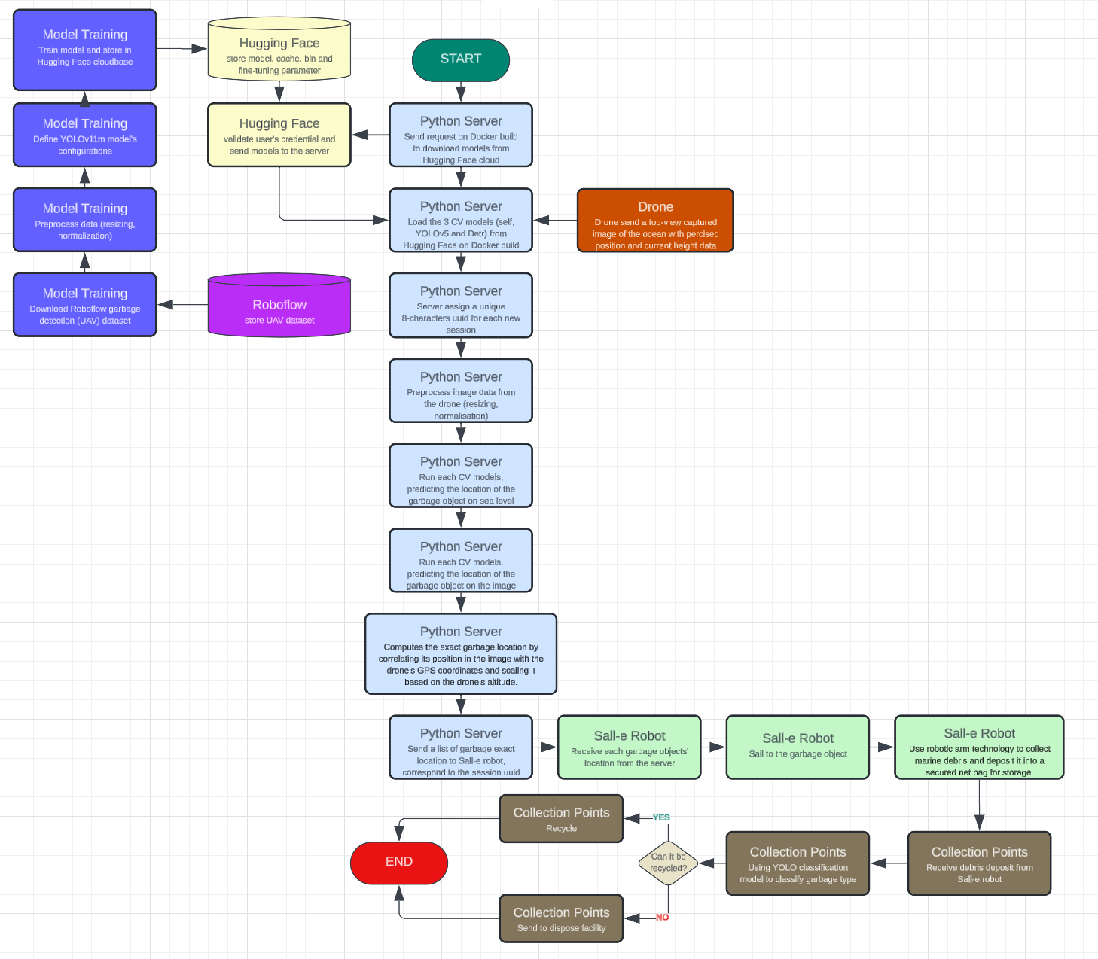

* User Manuals: Create comprehensive guides covering setup, operation, troubleshooting, and maintenance procedures for end-users.​
* Technical Documentation: Compile in-depth documents detailing system architecture, hardware specifications, and software dependencies.​.

# 10. References

[1] D. K. Le, "Sall-e: Autonomous Robot for Oceanic Garbage Collection," GitHub Repository, 2025. [Online]. Available: https://github.com/Lelekhoa1812/Sall-e

[2] D. K. Le, "Sall-eGarbageDetection," Hugging Face Space, 2025. [Online]. Available: https://huggingface.co/spaces/BinKhoaLe1812/Sall-eGarbageDetection

[3] "Great Pacific Garbage Patch," Wikipedia, 2025. [Online]. Available: https://en.wikipedia.org/wiki/Great_Pacific_Garbage_Patch

[4] "Marine Plastic Pollution," Wikipedia, 2025. [Online]. Available: https://en.wikipedia.org/wiki/Marine_plastic_pollution

[5] T. Can, "YOLOv5 Detect Trash Classification," Hugging Face Repository, 2025. [Online]. Available: https://huggingface.co/turhancan97/yolov5-detect-trash-classification

[6] Yorai, "DETR ResNet-50 Finetuned Detect Waste," Hugging Face Repository, 2025. [Online]. Available: https://huggingface.co/Yorai/detr-resnet-50_finetuned_detect-waste

[7] "Garbage Detection UAV Dataset," Roboflow Universe, 2025. [Online]. Available: https://universe.roboflow.com/roboflow-universe-projects/garbage-detection-uav

[8] "YOLOv11l Model," Ultralytics Hub, 2025. [Online]. Available: https://hub.ultralytics.com/models/yolov11l

[9] D. K. Le, "YOLOv11l: Garbage Detector," Ultralytics Hub, 2025. [Online]. Available: https://hub.ultralytics.com/models/EJpgcRoFDBIJW5pnhx6L

[10] "Transformers Library," Hugging Face, 2025. [Online]. Available: https://huggingface.co/transformers/

[11] "OpenCV: Open Source Computer Vision Library," OpenCV, 2025. [Online]. Available: https://opencv.org/

[12] "K-nearest neighbor algorithm in Python," GeeksForGeeks, 2025. [Online]. Available: https://www.geeksforgeeks.org/k-nearest-neighbor-algorithm-in-python/

[13] "A* Search Algorithm," GeeksForGeeks, 2025. [Online]. Available: https://www.geeksforgeeks.org/a-search-algorithm/

[14] D. K. Le, "Garbage Classification YOLO," Hugging Face Repository, 2025. [Online]. Available: <https://huggingface.co/datasets/BinKhoaLe1812/Garbage_Classification_YOLO>

[15] H. Sai, "Deploy Applications on Hugging Face Spaces," Hugging Face Blog, 2024. [Online]. Available: <https://huggingface.co/blog/HemanthSai7/deploy-applications-on-huggingface-spaces>

[16] "AI-Based Garbage Detection Research," 2025. [Online]. Available: <https://arxiv.org/abs/2311.05467>

[17] International Maritime Organization, "Autonomous Vessels and Maritime Regulations," 2025. [Online]. Available: <https://www.imo.org/en>

[18] National Oceanic and Atmospheric Administration (NOAA), "Marine Waste Collection Research," 2025. [Online]. Available: <https://www.noaa.gov/>

[19] "The Ocean Cleanup," *The Ocean Cleanup Project*, 2024. [Online]. Available: <https://theoceancleanup.com>.

[20] "SeaVax Autonomous Cleaning Vessel," *Bluebird Marine Systems*, 2021. [Online]. Available: <http://www.bluebird-electric.net/>.